Test Rail: It’s a test management tool

While Creating Project there are 3 options:

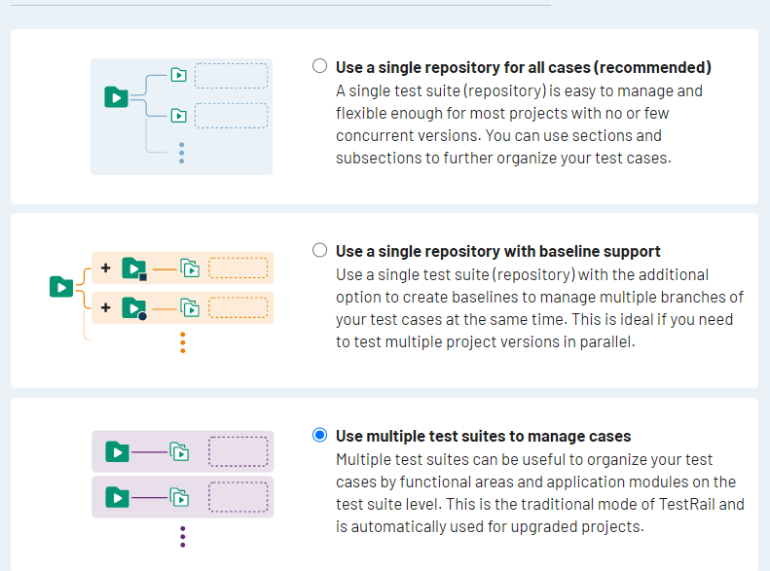

Recommedned will have only one Test Suite and All TC’s needs to added under that using category and Sub category

Baseline support is similar to Recommneded one

In Multiple Test Suite we can create multiple test suite add TC’s under each Test Suite

Milestone is nothing but any important release which we do as part of Project

In Test Plan we can set configuration and set multiple configuration for the specific release

In Test Run we can add TC’s and link to specific milestone